EQUATOR RESOLUTION
Institutional Family Mediation

Organisation Design & Hiring Plan
Roles, structure and a staffing ramp tied to the financial model

Family & Marital Dispute Resolution vertical
July 2026 · Draft for legal sign-off · www.equatorresolution.com

Design principles
- Small core, deep panel. Mediators are engaged per matter; the salaried core stays lean.
- Safety and quality are never outsourced. Safeguarding and quality assurance sit in-house from day one.
- Separation of duties. Case management, money (escrow) and quality audit are separate roles.
- Hire to volume, not to hope. Each hire is tied to a case-volume trigger in the financial model.
1. Structure
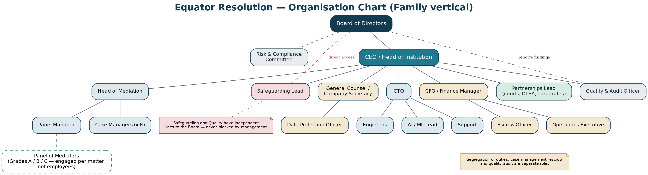
Figure — the organisation chart. Note the dashed lines: Safeguarding and Quality report findings directly to the Board, so neither can be blocked by management.
Function | Roles | Reports to
Leadership | CEO / Head of Institution | Board
Mediation | Head of Mediation; Panel Manager; Case Managers | CEO
Safeguarding & quality | Safeguarding Lead; Quality & Audit Officer | CEO (dotted line to Board)
Legal & compliance | General Counsel / Company Secretary; DPO | CEO / Board
Technology | CTO; Engineers; AI/ML lead; Support | CEO
Finance & operations | CFO/Finance Manager; Escrow Officer; Ops Executive | CEO
Growth | Partnerships (courts, DLSA, corporates); Content & outreach | CEO

2. Role descriptions (summary)
Head of Mediation
Purpose: Owns process quality, the panel and mediation standards. Profile: Senior family mediator; 12+ years; trainer capability; sets and audits standards.
Safeguarding Lead
Purpose: Owns screening, safety flags, incident response and support signposting. Profile: Social work / psychology / DV-sector background; independent voice to the Board.
Case Manager
Purpose: Runs cases end-to-end: intake, notice, scheduling, documents, closure. Profile: Empathetic, organised, legally literate; trained in screening basics and de-escalation.
Panel Manager
Purpose: Recruits, empanels, grades and reviews mediators; manages CPD. Profile: Recruitment plus quality-assurance mindset; understands the Bye-laws.
Quality & Audit Officer
Purpose: Samples cases and MSAs; runs the QMS; tracks corrective actions. Profile: Audit or compliance background; independent of case delivery.
General Counsel / CS
Purpose: Rules, forms, statutory compliance, court liaison, MCI application. Profile: Family-law literate; corporate secretarial capability.
Data Protection Officer
Purpose: DPDP compliance, DPIA, consent, breach response. Profile: Privacy qualification; may be combined with GC initially, then separated.
CTO
Purpose: Platform, security, integrations, AI governance. Profile: Built regulated or sensitive-data products; security-first.
AI/ML Lead
Purpose: RAG pipeline, prompts, guardrails, eval harness. Profile: Evaluation-driven; comfortable being told 'no' by the safety gate.
Escrow Officer
Purpose: Escrow instructions, milestone verification, reconciliation. Profile: Finance controls; segregation from case management.
Partnerships Lead
Purpose: Courts, DLSAs, legal aid, corporate and community channels. Profile: Credibility with the judiciary; patient, relationship-led.
3. Hiring ramp (tied to volume)
Phase | Case volume trigger | Hires added | Cumulative core
Phase 1 — build (M1–3) | Pre-launch | CEO, Head of Mediation, GC/CS, CTO, 1 Engineer, 1 Case Manager | 6
Phase 2 — pilot (M3–6) | First court pilot; ~20 cases/mo | Safeguarding Lead, Panel Manager, 1 Case Manager, AI/ML Lead | 10
Phase 3 — scale (M6–12) | ~60 cases/mo | 2 Case Managers, Quality & Audit Officer, Escrow Officer, Finance Manager, Support | 16
Phase 4 — expand (M12–24) | ~150 cases/mo | Partnerships Lead, DPO (separated), 2 Case Managers, 2 Engineers, Content | 23

Trigger discipline
No role is filled before its volume trigger is met, except the four that must exist before the first live matter: Head of Mediation, Safeguarding Lead, General Counsel and CTO. Safety and legal capability lead volume; everything else follows it.

4. Culture, diversity and wellbeing
- Panel and staff diversity is a quality requirement, not a nicety — parties should be able to find a mediator of their gender, language and community.
- Family mediation is emotionally heavy: build in supervision, reflective practice and vicarious-trauma support for mediators and case managers.
- Whistleblowing and speak-up routes independent of line management, with the Safeguarding Lead having direct Board access.

